ssUNIVERSITY OF TECHNOLOGY

School of Computing and Information Technology

Presented in Partial Fulfillment of the Course Requirement
Object-Oriented Programming using C++

“National Library Reference/User Database”

Group Members:
Xavier Lowe – 0802488
Dale McFarlane – 0801422
Robert Campbell – 0701334
Dyonne Duberry – 0802189
Audley Gordon – 0802218

Lecturer: D. White
Tutor: T. Edwards
Group: BSC2D
USER MANUAL
MAIN MENU
Upon insertion of the installation disc the user will automatically be presented with the program’s main Menu (Fig 1). The user should navigate (using Arrow or Tab Keys), and select the submenu they would like to enter.
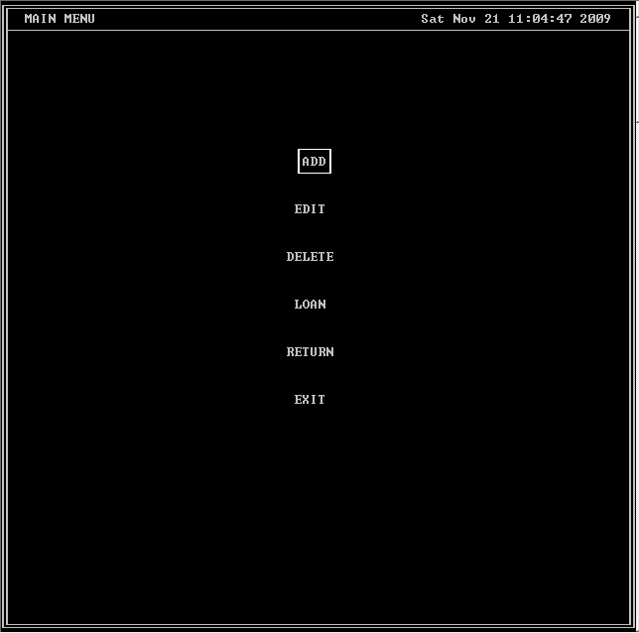
Fig 1 (Main Menu)
Select “ADD” in order to enter the credentials of the various library material (Research Paper, Text Book, Magazine) that are available.

ADD MENU
The user will be presented with the add credentials screen after selecting the type of item they would like to enter.(Fig 2)
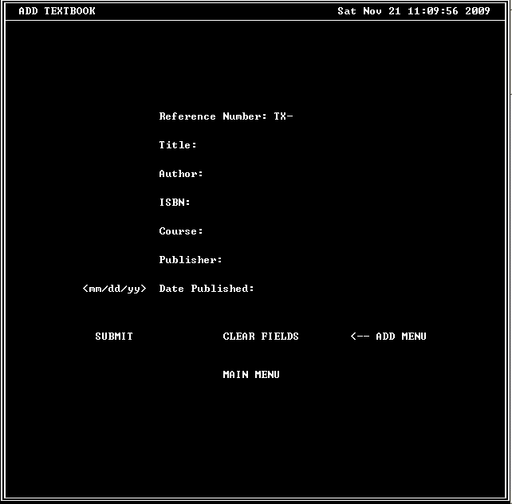
Fig 2 (Add Menu)
The data fields for that specific item should be filled out and the information will be saved once the “SUBMIT” option is selected. The user also has the option to clear the fields or return to the main menu if an error is made.

EDIT MENU
From the Main menu, the user also has the option to edit the credentials of library Material previously entered. (Fig3)
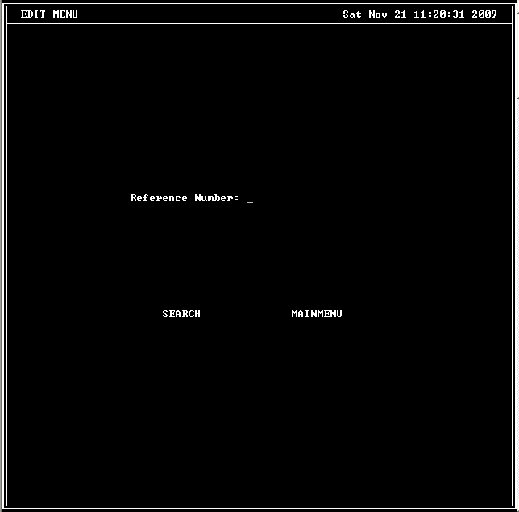
Fig 3 (EDIT MENU)
The Items reference number should be entered; the program will search for the data and present it for editing upon the selection of the “SEARCH” option. The user can also navigate back to the Main Menu.

DELETE MENU
If it becomes necessary to delete a reference item, the user should select “DELETE” from the Main Menu. The Delete Menu will then become available.(Fig 4)
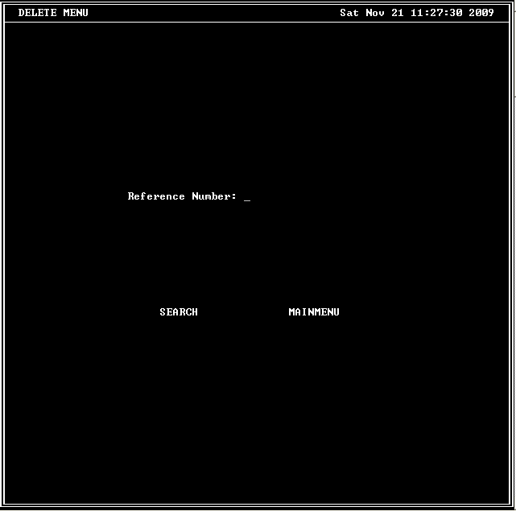
Fig 4 (DELETE MENU)
An item is deleted by entering and searching for that items reference number. The user also has the option to return to the main menu.

LOAN MENU
The loan menu allows the library to keep track of the reference material by storing information on the borrower, reference material and date. In order to borrow material, members should have a user account set up(Fig 5). The “New User Menu” allows this member data to be stored. After an account is set up, the user is able to borrow material (Fig 6)
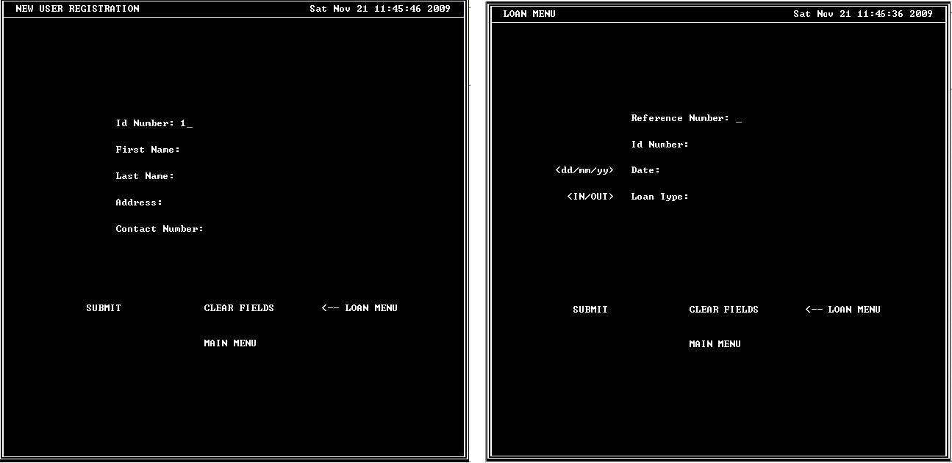
Fig 5 (NEW USER) Fig 6 (Existing User/Loan Menu)

The Member’s ID number and the Reference Number of the item they wish to borrow are required to complete the Loan.

RETURN MENU
When a library member wishes to return an item, the program user should select “RETURN” from the Main Menu. The Return Menu will be presented. (Fig 7)

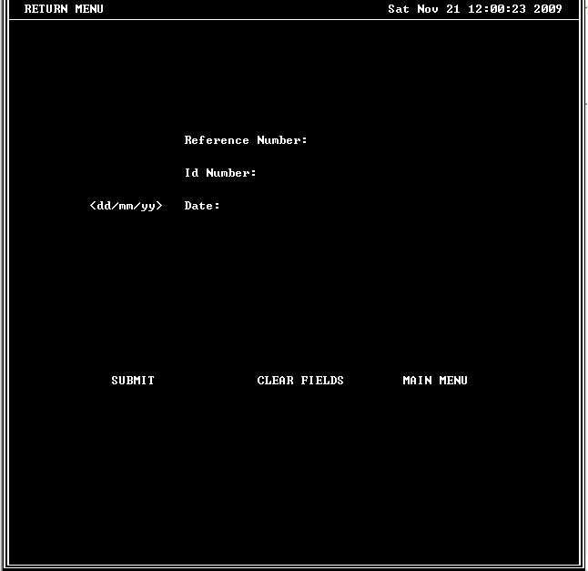
Fig 7 (Return Menu)
The members ID number and the items reference number fields are required. After entering this information, the user should select “SUBMIT” so that the data will be updated. The user may then return to the Main Menu and select another action or select “EXIT” to terminate the application.

